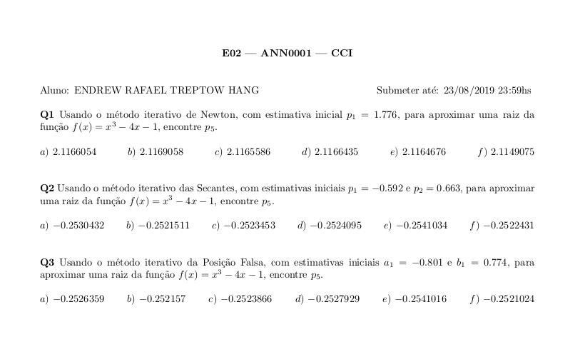
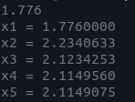
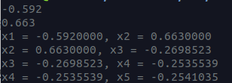
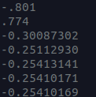
Ex 01) Ex 02) Ex 03)

Codigo 1)

#include <stdio.h>
#include <math.h>

double func(double x){
return pow(x, 3) - 4*x -1;
}

double derfunc(double x){
return 3 * pow(x, 2) - 4;
}

int main(){
double p1, res;
scanf("%lf", &p1);
res = p1;
for (size_t i = 1; i <= 5; i++)
{
printf("x%lu = %.7lf\n", i, res);
res = res - func(res) / derfunc(res);
}
}

Codigo 2)

#include <stdio.h>
#include <math.h>

double func(double x){
return pow(x, 3) - 4*x -1;
}

int main(){
double x[6];
scanf("%lf%lf", &x[0], &x[1]);
for (size_t i = 1; i < 5; i++)
{
printf("x%lu = %.7lf, x%lu = %.7lf\n", (i), x[i - 1], (i + 1), x[i]);
x[i + 1] = -x[i] * func(x[i - 1]) + x[i - 1] * func(x[i]);
x[i + 1] /= (func(x[i]) - func(x[i - 1]));
}
}

Codigo 3)

#include <stdio.h>
#include <math.h>

double func(double x){
return pow(x, 3) - 4*x -1;
}

int main(){
double x, y;
double xn;
scanf("%lf%lf", &x, &y);
for(int i=0;i<5;i++){
xn = x*func(y) - y*func(x);
xn /= (func(y) - func(x));
if(func(xn)*func(x) < 0)
y = xn;
else
x = xn;
printf("%.8lf\n", xn);
}
}

